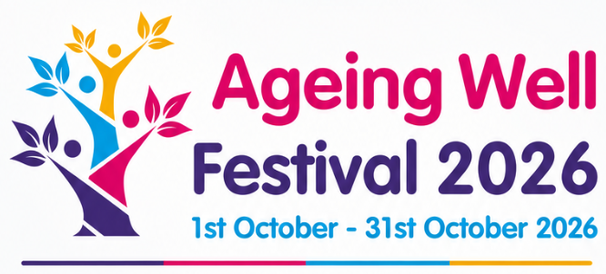

Celebrating Ageing Well in Dudley: Wellness is Ageless!
Call to Action to help us showcase what we have to offer in Dudley Borough.
A bit of information about your group
Name of the group
Name of organisation delivering group (if different from above (if it’s the same, just put N/A in the answers)

Briefly explain what your group does (what is its main aim)?

When, where and how often do you meet (frequency e.g. weekly, monthly, twice a week etc.)? | When (days of the week):  Frequency (how often):
Which towns do your groups meet in (Dudley/Brierley Hill/Stourbridge, Halesowen/some of these/all of these?
Address of the venue(s) your groups meet in
Does your group focus on any particular members of the community (e.g. specifically for Afro-Caribbean members, specific genders, or is it open to all people from all walks of life)?

How would you like to be involved in our Ageing Well Festival (between 1st October and 31st October 2026)?
I would like to advertise our group(s) (information only) but not open it up to new members to join as part of the festival | Yes/No (if you answer yes then the other two below don’t apply and we will just showcase your group without any joining details)
I would like to advertise our existing group(s) and welcome new members to join as part of the festival | Yes/No (if yes, please explain how):
I would like to organise a specific activity/group/event just for the Ageing well festival and give you the details so that Citizens Advice can advertise the details for members of the public to attend | Yes/No (if yes, please explain)
Other (if you identify something different to the above that you would like to do)
If yes to the previous 3 questions, please confirm:

What is your capacity (i.e. how many more people could attend, on top of your normal group allocation)?

How would individuals book on to attend (do they just turn up, or is there a booking process, if so please elaborate)?

Is there a cost element involved to attend your group on this occasion?

Would you be happy for us to share the details of the Ageing Well Festival with you, when all arranged, so you can help us spread the word?
No, please don’t send us any posters/leaflets to hand out or to display | Say here if it’s a No
Yes, more than happy to advertise and spread the word! | Please indicate which one applies to you:  Yes – we can email the information on but won’t need hard copies to hand out  Yes – just email us the information and we can print out copies of posters, leaflets to hand out  Yes – But we will need you to give us hard copies of posters, leaflets to hand out

Contact details (so we can get in touch about next steps)
Contact name(s) | Person 1  Person 2 (if applicable)
Contact email(s) | Person 1  Person 2 (if applicable)
Contact phone number(s) | Person 1  Person 2 (if applicable)
Can we contact you anytime or are there better days of the week to contact you?

Do you give permission for your details to be used for promoting your activities/group for the Ageing Well Festival
Date

Name

Signature
What happens next?
Once you have emailed this back to HealthAndWellbeing@dudleycabx.org, we will be in touch about next steps. Alternatively, if email is a problem you can ring Shamim on: 07976637354 and talk through the answers. Thank you in advance for completing this and wanting to be a part of the exciting Ageing Well Festival in Dudley Borough in October 2026!

